DBMS ASSIGNMENT

1) Referential integrity is established with the primary key of lookup table to get better reliablity of data.It is one of the type of range control in which the value of that field should be filled by some other field in another row of the same or different table.

SQL Query

CREATE TABLE Section_T

(SectionNO NUMBER NOT NULL ,

Semester CHAR(7) NOT NULL ,

CourseID CHAR(8) ,

CONSTRAINT Section_PK PRIMARY KEY(CourseID, SectionNo,Semester),

CONSTRAINT Section_FK FOREIGN KEY (CourseID) REFERENCES Course_T(CourseID));

2) A) Create two different forms of the INSERT command to add a student with a student ID of 65798 and last name Lopez to the Student table
SELECT Student.ID, Student.Name

FROM Student WHERE (((Student.ID)=65798) AND ((Student.Name)="Lopez"));

- A command that will remove Lopez from the Student table. DELETE Student.ID, Student.Name

FROM Student WHERE (((Student.Name)="Lopez"));

- A command that will modify the name of course ISM 4212 from Database to Introduction to Relational Database.

SELECT Course.ID, Course.Name

FROM Course WHERE (((Course.ID)="ISM 4212"))

ORDER BY Course.ID;

3) A)what are the courses included in the Section table? List each course only once

SELECT Section.CourseID, Course.Name

FROM [Section], Course;

B) List all students in alphabetical order by StudentName.

SELECT Student.Name

FROM Student

ORDER BY Student.Name;

C) List the students who are enrolled in each course in semester 1/2008. Group the students by the sections in which they are enrolled.

SELECT COUNT (DISTINCT (StudentID))

FROM Registration

WHERE SectionID = 2714

AND Semester = ‘I-2008’

D) List the courses available. Group them by course prefix. (ISM is the only prefix shown, but there are many others throughout the university.)

SELECT DISTINCTCourseName

FROM COURSE
WHERE CourseID IN( SELECT CourseID FROM SECTION);

4) The query used to find how many students matched someone in the first five months SELECT COUNT (StudentID) AS COUNTOfStudent

FROM MatchHistory_Table

WHERE StartDate BETWEEN '01-JAN-2008' AND '31-MAY-2008';

5)

SELECT TO_CHAR (TutorReport.Month, 'MONTH') MONTH,

TutorReport.MatchID, MatchHistory.MatchID,

MatchHistory.Tutor.ID FROM TutorReport,

MatchID WHERE TutorReport.MatchID=MatchHistory.MatchID

AND NOT (TutorReport.Month=‘JULY’)

6)

SELECT c.customer_id

FROM customer_t c

WHERE c.customer_id not in (select distinct o.customer_id from order_t o);
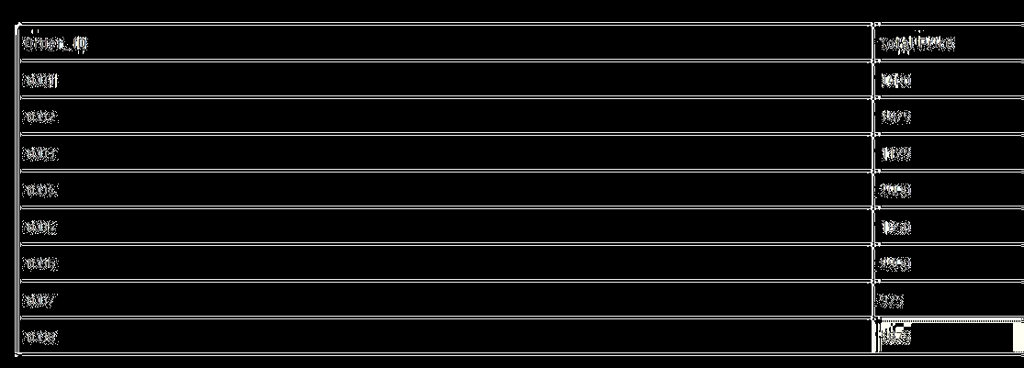

7)

SELECT ORDER_t.Order_ID, ORDER_t.Customer_ID, ORDER_t.Order_Date,

Order_line_t.Product_ID, PRODUCT_T.Product_Description, Order_line_t.Ordered_Quantity

FROM Order_line_t, ORDER_t, PRODUCT_t

WHERE ORDER_t.Order_ID=Order_line_t.Order_ID AND

ORDER_line_t.Product_ID=PRODUCT_t.Product_ID AND

ORDER_t.Order_ID = 1;

